**ReactJS Evergreen Component**

npm install evergreen-ui

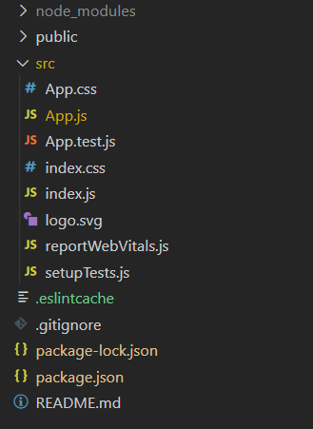

*Project Structure*

**App.js**

import React from 'react'

import { Autocomplete, TextInput } from 'evergreen-ui'

export default function App() {

  return (

    <div style={{

      display: 'block', width: 700, paddingLeft: 30

    }}>

      <h4>ReactJS Evergreen Autocomplete Component</h4>

      <Autocomplete

        title="Weekdays"

        items={['Monday', 'Tuesday', 'Wednesday', 'Thursday',

                'Friday', 'Saturday', 'Sunday']}

      >

        {props => {

          return (

            <TextInput

              placeholder="Enter Weekday"

              ref={props.getRef}

              value={props.inputValue}

              {... props.getInputProps()}

            />

          )

        }}

      </Autocomplete>

    </div>

  );

}

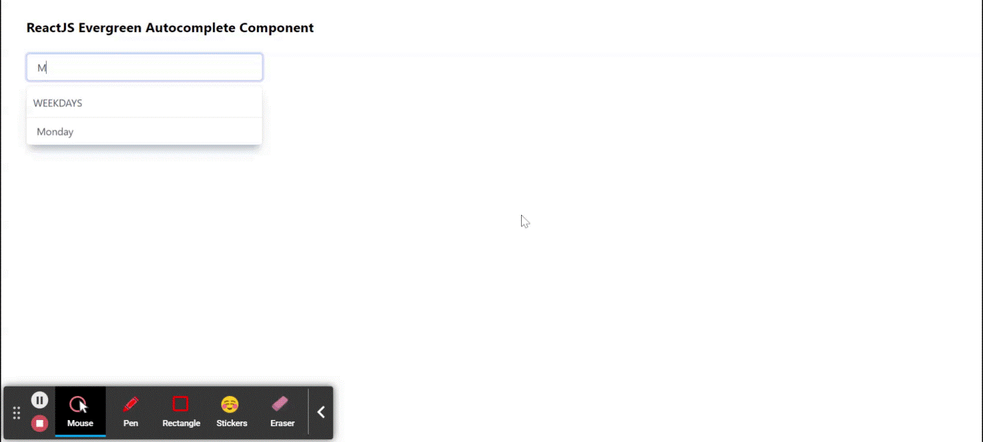

# Combobox

|  |
| --- |
| import React from 'react'  import { Combobox } from 'evergreen-ui'    export default function App() {    return (      <div style={{        display: 'block', width: 700, paddingLeft: 30      }}>        <h4>ReactJS Evergreen Combobox Component</h4>        <Combobox          placeholder="Select Week Days"          items={['Monday', 'Tuesday', 'Wednesday', 'Thursday',           'Friday', 'Saturday', 'Sunday']}          autocompleteProps={{            title: 'Weekdays'          }}        />      </div>    );  } |

**Output:**Now open your browser and go to***http://localhost:3000/***, you will see the following output:

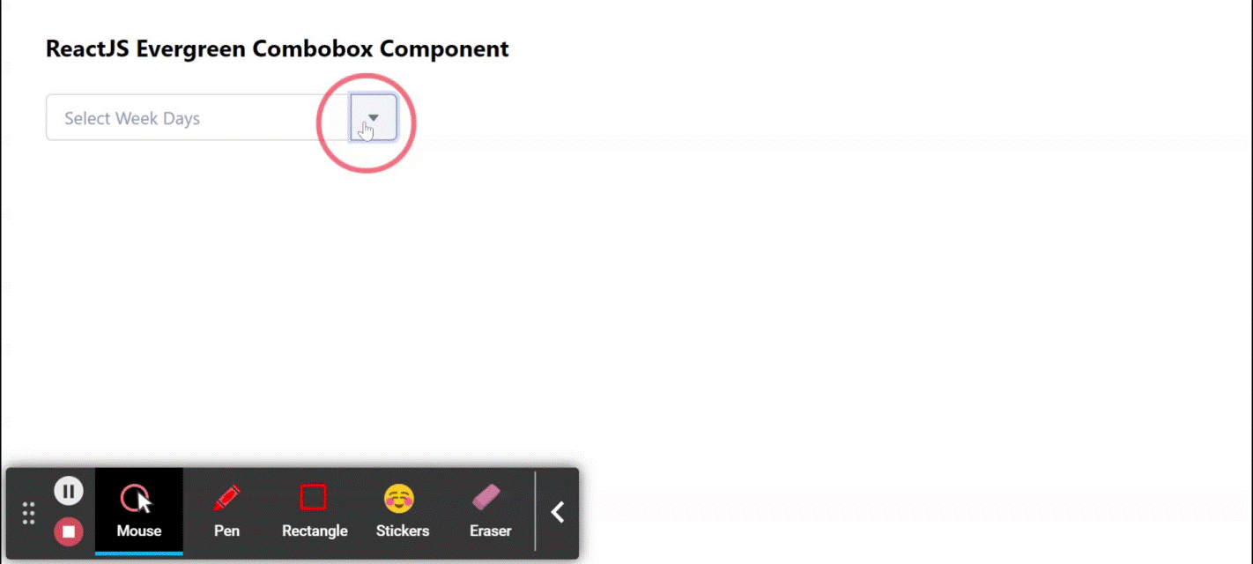

# Tab Component

import React from 'react'

import { Pane, Tab, Tablist } from 'evergreen-ui'

export default function App() {

  // State for Selected Index

  const [indexSelected, setIndexSelected] = React.useState(0)

  // Tabs Heading Array

  const [tabsHeading] = React.useState(['Tab 1', 'Tab 2', 'Tab 3'])

  // Tabs Content Array

  const [tabsContent] = React.useState(['Content of Tab 1',

    'Content of Tab 2', 'Content of Tab 3'])

  return (

    <div style={{

      display: 'block', width: 700, paddingLeft: 30

    }}>

      <h4>ReactJS Evergreen Tab Component</h4>

      <Pane height={120}>

        <Tablist marginBottom={20} >

          {tabsHeading.map((tab, index) => (

            <Tab

              key={tab}

              isSelected={index === indexSelected}

              onSelect={() => setIndexSelected(index)}

            >{tab}</Tab>

          ))}

        </Tablist>

        <Pane background="lightblue" flex="1">

          {tabsContent.map((tab, index) => (

            <Pane

              role="tabpanel"

              key={tab}

              display={index === indexSelected ? 'block' : 'none'}

            >{tab}</Pane>

          ))}

        </Pane>

      </Pane>

    </div>

  );

}

output

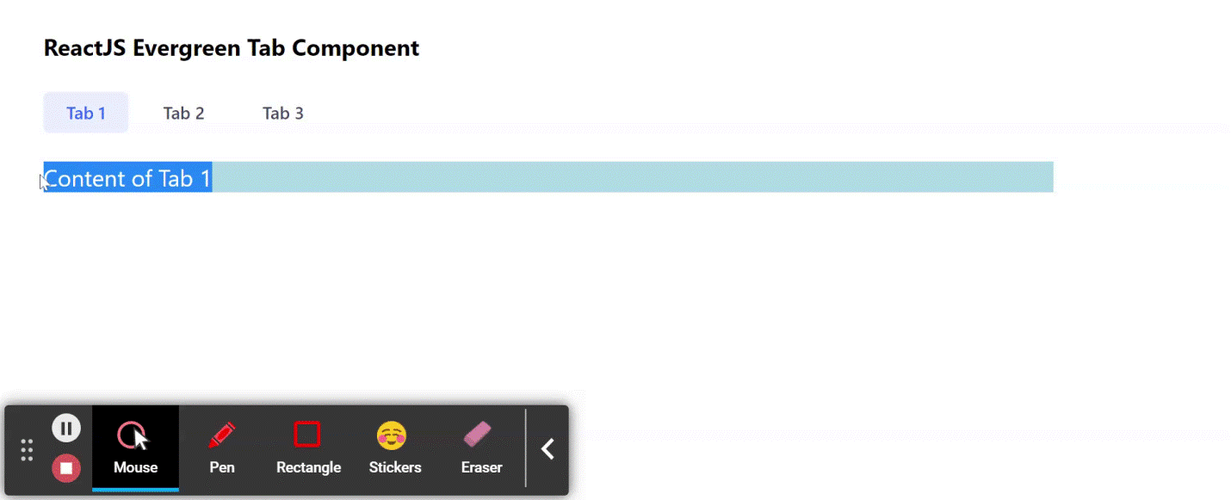

# SelectMenu

import React from 'react'

import { SelectMenu, Button } from 'evergreen-ui'

export default function App() {

  // State for selected

  const [selected, setSelected] = React.useState(null)

  // Sample Options

  const options = [

    { label: 'Monday', value: 'Monday' },

    { label: 'Tuesday', value: 'Tuesday' },

    { label: 'Wednesday', value: 'Wednesday' },

    { label: 'Thursday', value: 'Thursday' },

    { label: 'Friday', value: 'Friday' },

    { label: 'Saturday', value: 'Saturday' },

    { label: 'Sunday', value: 'Sunday' },

  ]

  return (

    <div style={{

      display: 'block', width: 700, paddingLeft: 30

    }}>

      <h4>ReactJS Evergreen SelectMenu Component</h4>

      <SelectMenu

        selected={selected}

        options={options}

        title="Select week day"

        onSelect={(item) => setSelected(item.value)}

      ><Button> {selected || `Select Weekday`}</Button>

      </SelectMenu>

    </div>

  );

}

output